Cranberry Facial
by Envirogroom Pet Products
Choose Natural!

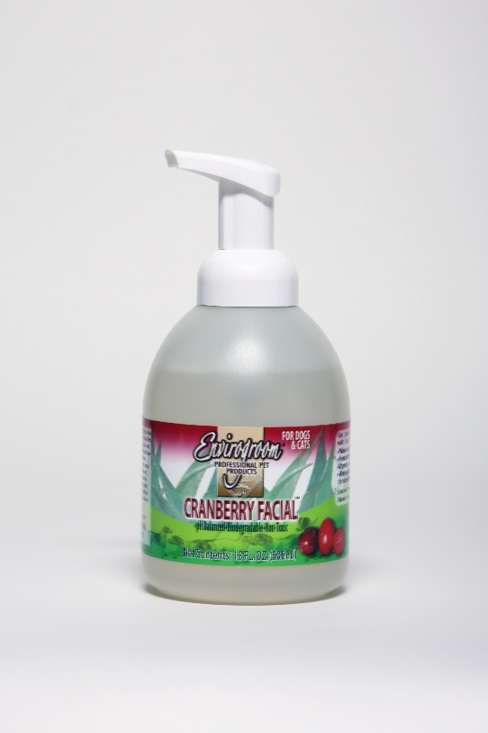
Hypo-Allergenic & Tearless
Helps remove unwanted odors around pets face safely
Noticeable reduction in tear staining
Safe for Dogs, Cats, Kittens, Puppies & Horses
Wheat, Gluten and Paraben Free
Leaves a nice cranberry scent

