Foot Soak
Helps relieve itchy, sore feet and pads
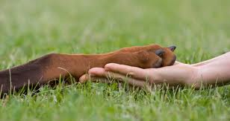
Included in Special:
- 5 minute warm foot soak in Neem Supreme Anti-Itch Relief
- Pumice stone to smooth cracked, tired pads
- Foot Balm Massage
- Nail Filing

