Does Your Pet ALWAYS Shed?
Try our mini-de-shed that will:
- reduce shedding
- leave a great berry smell
- with a super soft coat

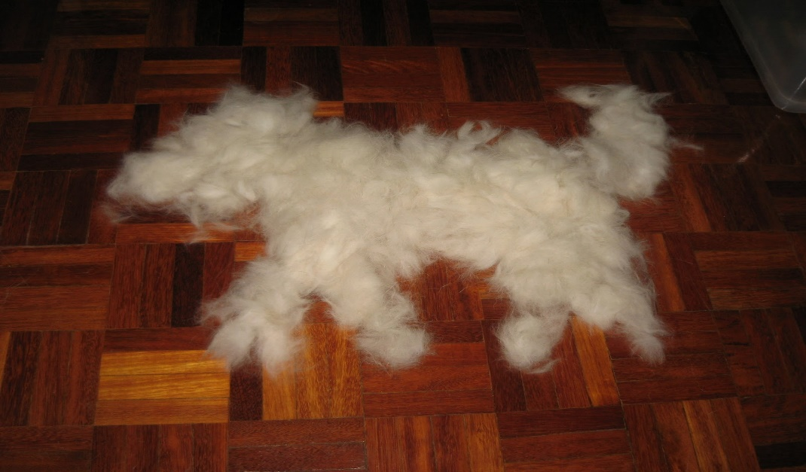
Ask about our
Berry Silk Blowout

