Envirogroom Pet Products
Choose Natural

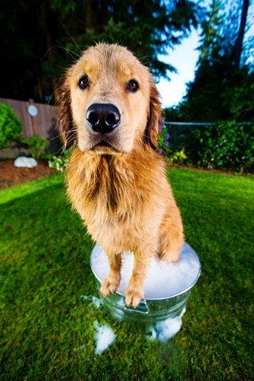
Safe for Dogs, Cats, Kittens, Puppies & Horses
Wheat, Gluten and Paraben Free
Certified Organic Aloe
Ph Balanced; Vitamin and Protein Fortified
Always Gentle and Mild for Sensitive Skin
High Dilution Ratio Makes Envirogroom and Exceptional Value

