Fall Package $10
Have Your Pups Smelling Like Apples While
the Weather Cools and the Leaves Fall!!!
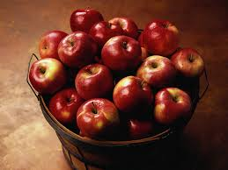
Package Includes:
Facial
Shampoo
Conditioner
Finishing Spray
Cologne

